**FRIO COUNTY COMMISSIONERS COURT MINUTES FOR**

**Regular Meeting August 29th, 2023**

On the 29th day of August, 2023, at 3:00 p.m., the Commissioners Court of Frio County met in a regular meeting with the following members either absent or present, to-wit: Rochelle Lozano Camacho, Frio County Judge was present; Joe Vela, Commissioner Pct 1 present; Mario Martinez, Commissioner Pct 2 present; Raul Carrizales, Commissioner Pct 3 present; Danny Cano, Commissioner Pct 4 present; Joseph A. Sindon, Legal Counsel for Frio County Commissioners Court present; and Aaron Ibarra, Frio County Clerk present when the following meeting was held, to-wit: The meeting can be seen unedited and to its full extent on our county website, under the County Clerk tab.

I. Invocation and Pledge of Allegiance

II. Adopt Agenda

**APPROVE WITH THE OMISSION OF 7&15**

**MOTION: COMMISSIONER CARRIZALES**

**SECOND: COMMISSIONER CANO**

**MOTION PASSED**

III. Old Business

**PRESENTATION**

**ACTION AGENDA ITEMS**

IV. General Discussion

V. Citizens To Be Heard

**NONE**

VI. New Business

**PRESENTATION**

(1) Ronald Rocha, Attorney at Law, Linebarger Goggan Blair & Sampson, LLP**,** requests:

Update on the delinquent fines and collection services by Linebarger Goggan Blair & Sampson LLP.

**PRESENTATION HEARD, NOTHING OF SIGNIFICANCE NOTED**

(2) Hon. Raul Carrizales, III. Frio County Commissioner, Precinct No. 3, requests:

Presentation of monthly statistics reports compiled by ShureMed.

**PRESENTATION HEARD. NOTHING OF SIGNIFICANCE WAS HEARD**

**ACTION AGENDA ITEMS**

(1) Robert Carter with Leal & Carter, P.C., requests:

1.1 Present Frio County audited financial statements for fiscal year 2021-2022.

1.2 Take action if necessary.

**APPROVE**

**MOTION: COMMISSIONER CARRIZALES**

**SECOND: COMMISSIONER CANO**

**MOTION PASSED**

(2) Hon. Crystal Marquez, Frio County Auditor, requests:

Consider / take action on opening Proposals received by the specified deadline for Ground Emergency Medical Ambulance Service.

**PROPOSALS OPENED, WILL BE REVIEWED AND BROUGHT BACK**

(3) Hon. Crystal Marquez, Frio County Auditor, requests:

Consider / take action on opening Bids received by the specified deadline for Fuel & Road Materials.

**PROPOSALS OPENED, WILL BE REVIEWED AND BROUGHT BACK**

(4) Ramiro Trevino, Frio County Human Resources Director requests:

4.1 Presentation from Biral Patel, Texas Association of Counties Wellness Consultant regarding the T.A.C. Healthy County: County Specific Incentive Program

4.2 Consider/take action on approving the implementation of T.A.C. Healthy County: County Specific Incentive Program, and authorize Hon. Rochelle Camacho, County Judge to execute all documents necessary to enroll Frio County in the incentive program.

**APPROVE**

**MOTION: COMMISSIONER CARRIZALES**

**SECOND: COMMISSIONER CANO**

**MOTION PASSED**

(5) Hon. Mike Morse, Frio County Sheriff, requests:

Consider and approve the acceptance of a $1000.00 donation from Mr. Curt Mclain of Dilley Lube and Tire for the Sheriff’s Office Donation fund.

**APPROVE**

**MOTION: COMMISSIONER CANO**

**SECOND: COMMISSIONER CARRIZALES**

**MOTION PASSED**

(6) Hon. Mike Morse, Frio County Sheriff, requests:

6.1 Consider/take action on approving an Intergovernmental Agreement by and between Frio County and Medina County for the Housing of Inmates.

6.2If the agreement is approved, consider/take action on signing a resolution authorizing Hon. Rochelle Camacho, Frio County Judge to sign same on behalf of Frio County.

**APPROVE**

**MOTION: COMMISSIONER MARTINEZ**

**SECOND: COMMISSIONER VELA**

**MOTION PASSED**

(7) Hon. Aaron Ibarra, Frio County Clerk, requests:

7.1 Review Frio County Commissioners Court minutes for July 11, 17, 18, 19, 20, 25, and August 8, 2023.

7.2 Consider/Approve Frio County Commissioners Court minutes for July 11, 17, 18, 19, 20, 25, and August 8, 2023.

**TABLED, WILL BE BROUGHT BACK**

(8) Hon. Aaron Ibarra, Frio County Clerk, requests:

8.1 Consider/take action on the adoption of a County Clerk Records

Archive fee - $10.00 pursuant to Tex. Gov’t Code § 51.305 County Clerk Records Technology Fund.

8.2 Consider/take action on setting a public hearing date for the adoption of the Frio County Clerk Archive Plan for September 26, 2023.

**APPROVE**

**MOTION: COMMISSIONER CARRIZALES**

**SECOND: COMMISSIONER CANO**

**MOTION PASSED**

(9) Hon. Ofilia M. Trevino, Frio County District Clerk, requests:

9.1 Consider/take action on adoption of a District Court Records Archive Fee - $10.00 – Tex. Gov’t Code § 51.305(b).

**APPROVE**

**MOTION: COMMISSIONER MARTINEZ**

**SECOND: COMMISSIONER VELA**

**MOTION PASSED**

9.2 Consider/take action on adoption of a payment amount of $60.00 for jury service.

**APPROVE**

**MOTION: COMMISSIONER CARRIZALES**

**SECOND: COMMISSIONER CANO**

**MOTION PASSED**

(10) Carlos Segura, Frio County Elections Administrator, requests:

Consider/take action on approving, as per Tex. Elec. Code § 32.083, an Order to set the Compensation Rate for Election Workers updating the compensation rate for Election judges, alternate judges, and clerks.

**APPROVE**

**MOTION: COMMISSIONER CARRIZALES**

**SECOND: COMMISSIONER CANO**

**MOTION PASSED**

(11) Carlos Segura, Frio County Elections Administrator, requests:

Consider/take action on approving an Order of Special Election for the 2023 Constitutional Amendment Election.

**NO ACTION**

(12) Carlos Segura, Frio County Elections Administrator, requests:

Consider/take action on approving anOrder to Amend the Appointment of Election Judges and Alternates for a two-year term that started on October 1, 2022 and due to expire on October 1, 2024 in accordance with Tex. Elec. Code § 32.009.

**APPROVE**

**MOTION: COMMISSIONER CANO**

**SECOND: COMMISSIONER MARTINEZ**

**MOTION PASSED**

(13)  Hon. Rochelle Camacho, Frio County Judge, requests:

13.1 Consider/take action on approving a Master Agreement for SaaS Participation in TechShare and Software as a Service Addendum.

13.2 If the agreement is approved, consider/take action on signing resolution allowing Frio County Judge Rochelle Camacho to enter into same and all other necessary documents on behalf of Frio County.

**APPROVE 7:30 A.M.-10 P.M.**

**MOTION: COMMISSIONER CARRIZALES**

**SECOND: COMMISSIONER CANO**

**MOTION PASSED**

(14) Hon. Raul Carrizales, III.  Frio County Commissioner Pct. 3, Requests:

Consider/take action on adjusting the closing hours for Frio County Parks.

**APPROVE**

**MOTION: COMMISSIONER CANO**

**SECOND: COMMISSIONER MARTINEZ**

**MOTION PASSED**

(15) Hon. Raul Carrizales, III.  Frio County Commissioner Pct. 3, Requests:

Consider/take action on waiving fees for the use of the Frio County Conference Room by the Pearsall Pee Wee Sports organization on August 5, 2023.

**NO ACTION**

(16) Ancelmo Ornelas, Frio County Road and Bridge Administrator, requests:

Consider/take action to waive the fee of $75.00 for the use of the Fireman’s Park by the Pearsall Volunteer Fire Department on October 3, 2023 to host National Night Out. The event will have stand setups, food, DJ and fire prevention activities from 5:30 p.m. to 9:00 p.m.

**APPROVE**

**MOTION: COMMISSIONER CANO**

**SECOND: COMMISSIONER MARTINEZ**

**MOTION PASSED**

(17) Tommy Navarro, Frio County Facilities Management Supervisor, requests:

Consider/take action on selecting a contractor to replace the roof shingles and a broken window due to hail damage at the Dilley Road & Bridge Office located at 1595 W 117, Dilley, Texas.

**APPROVE**

**MOTION: COMMISSIONER CANO**

**SECOND: COMMISSIONER MARTINEZ**

**MOTION PASSED**

(18) Hon. Crystal Marquez, Frio County Auditor, requests:

Consider / take action to approve the 2023-2024 Proposed Tax Rate:

**Proposed Tax Rate: = $0.596800/$100**

No-New-Revenue Tax Rate: = $0.527000/$100

Voter-Approval Tax Rate: = $0.690879/$100

De Minimis Rate: = $0.541520/$100

**APPROVE**

**MOTION: COMMISSIONER MARTINEZ**

**SECOND: COMMISSIONER CANO**

**MOTION PASSED**

(19) Hon. Crystal Marquez, Frio County Auditor, requests:

Consider/take action on approving and signing a resolution authorizing a grant of $4,392.50 to the Home Delivered Meal Grant Program run by the Texas Department of Agriculture.

**APPROVE**

**MOTION: COMMISSIONER CARRIZALES**

**SECOND: COMMISSIONER MARTINEZ**

**MOTION PASSED**

(20) Hon. Crystal Marquez, Frio County Auditor, requests:

Consider / take action on approving online applications for two safety lights at CR 2010 & CR 2000, and CR2015 & CR 2000 in Pearsall, TX 78061 as previously approved, including engineering fees for $100.00 each.

**APPROVE**

**MOTION: COMMISSIONER MARTINEZ**

**SECOND: COMMISSIONER CARRIZALES**

**MOTION PASSED**

(21) Hon. Crystal Marquez, Frio County Auditor, requests:

Consider / take action on approving the Frio County Fuel Card Issuance Form to be effective August 29, 2023.

**APPROVE**

**MOTION: COMMISSIONER CARRIZALES**

**SECOND: COMMISSIONER CANO**

**MOTION PASSED**

(22) Hon. Crystal Marquez, Frio County Auditor, requests:

Consider/take action on approving the Frio County Federal Procurement Procedures to be effective August 29, 2023.

**APPROVE**

**MOTION: COMMISSIONER MARTINEZ**

**SECOND: COMMISSIONER CARRIZALES**

**MOTION PASSED**

(23) Hon. Crystal Marquez, Frio County Auditor, requests:

Consider / take action on approving the revised Frio County Purchasing Card Policy and Procedure to be effective August 29, 2023.

**APPROVE**

**MOTION: COMMISSIONER CARRIZALES**

**SECOND: COMMISSIONER CANO**

**MOTION PASSED**

(24) Hon. Crystal Marquez, Frio County Auditor, requests:

Consider / take action on approving the revised Cellular Phone Policy to be effective August 29, 2023.

**APPROVE**

**MOTION: COMMISSIONER CANO**

**SECOND: COMMISSIONER MARTINEZ**

**MOTION PASSED**

(25) Hon. Crystal Marquez, Frio County Auditor, requests:

Consider / take action on approving the revised Purchasing and Debarment Policies & Procedures to be effective August 29, 2023.

**APPROVE**

**MOTION: COMMISSIONER CARRIZALES**

**SECOND: COMMISSIONER CANO**

**MOTION PASSED**

(26) Hon. Crystal Marquez, Frio County Auditor, requests:

Discuss and/or take appropriate action to certify the revenue received, $178,000 under the General Fund (fund 100) and add the following line items to the 2022-2023 Budget to receipt the funds and allow expenses:

Account #: **100-40000.4361** Operation Stonegarden Grant

Account Name: Revenues

Account #: **100-58612.5120** Salaries – OPSG Deputies

Account Name: Special Projects

Account #: **100-58612.5131** Payroll Taxes                        

Account Name: Special Projects

Account #: **100-58612.5151** Co. Retirement Contribution 

Account Name: Special Projects

Account #: **100-58612.5156** County Retirement Supplement

Account Name: Special Projects

Account #: **100-58612.5161** Workers Comp. Insurance    

Account Name: Special Projects

Account #: **100-58612.5171** Unemployment                     

Account Name: Special Projects

**APPROVE**

**MOTION: COMMISSIONER MARTINEZ**

**SECOND: COMMISSIONER CARRIZALES**

**MOTION PASSED**

(27) Hon. Crystal Marquez, Frio County Auditor, requests:

27.1 Consider/take action on approving online credit application with Kyrish.

27.2 If the agreement is approved, consider/take action on approving a resolution authorizing Hon. Rochelle Camacho, Frio County Judge, authority to sign same on behalf of Frio County.

**APPROVE**

**MOTION: COMMISSIONER MARTINEZ**

**SECOND: COMMISSIONER CARRIZALES**

**MOTION PASSED**

(28) Hon. Crystal Marquez, Frio County Auditor, requests:

Consider / take action on approving quote number 29035009 to Deere & Company for the purchase of a John Deere 5100E tractor, including a John Deere FC15R Flex Wing Rotary Cutter, and Powergard Protection Plan for a total cost of $97,382.02. This is state approved under the BuyBoard 706-23 contract.

**APPROVE**

**MOTION: COMMISSIONER MARTINEZ**

**SECOND: COMMISSIONER CANO**

**MOTION PASSED**

(29) Hon. Crystal Marquez, Frio County Auditor, requests:

Consider/take action on approving a Modification Order with Spectrum Enterprise for one new native BCP fax line for a total monthly cost of $29.99 and a one-time payment of $178.98 at 101 N. Commerce Street Dilley, Texas.

**APPROVE**

**MOTION: COMMISSIONER CANO**

**SECOND: COMMISSIONER CARRIZALES**

**MOTION PASSED**

(30) Hon. Crystal Marquez, Frio County Auditor, requests:

30.1 Consider / take action to approve the budget amendments to the FISCAL YEAR 2022-2023 Frio County Budget, list below:

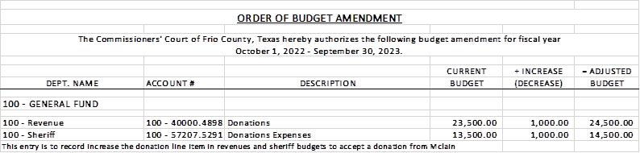

30.2 If the amendment is approved, consider/take action on signing order stating same.

**APPROVE**

**MOTION: COMMISSIONER MARTINEZ**

**SECOND: COMMISSIONER CANO**

**MOTION PASSED**

(31) Hon. Crystal Marquez, Frio County Auditor, requests:

31.1 Consider / take action to approve the budget amendments to the FISCAL YEAR 2022-2023 Frio County Budget, list below:

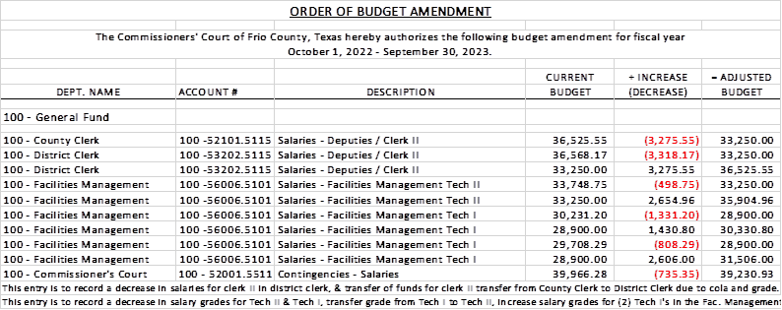

31.2 If the amendment is approved, consider/take action on signing order stating same.

**APPROVE**

**MOTION: COMMISSIONER MARTINEZ**

**SECOND: COMMISSIONER CARRIZALES**

**MOTION PASSED**

(32) Hon. Crystal Marquez, Frio County Auditor, requests:

32.1 Consider / take action to approve the budget amendments to the FISCAL YEAR 2022-2023 Frio County Budget, list below:

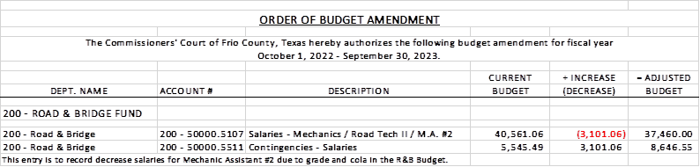

32.2 If the amendment is approved, consider/take action on signing order stating same.

**APPROVE**

**MOTION: COMMISSIONER CARRIZALES**

**SECOND: COMMISSIONER CANO**

**MOTION PASSED**

(33) Hon. Crystal Marquez, Frio County Auditor, requests:

33.1 Consider / take action to approve the budget amendments to the FISCAL YEAR 2022-2023 Frio County Budget, list below:

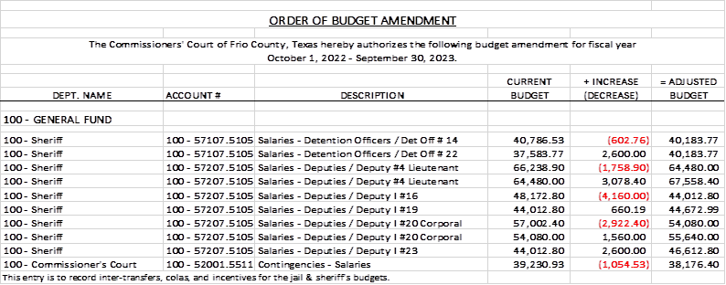

33.2 If the amendment is approved, consider/take action on signing order stating same.

**APPROVE**

**MOTION: COMMISSIONER MARTINEZ**

**SECOND: COMMISSIONER CARRIZALES**

**MOTION PASSED**

(34) Hon. Mike Morse, Frio County Sheriff, requests:

Consider/take action on approving proposal #165903 from ProComputing to purchase one ActivPanel 75” with wall mount, including Promethean, 5-year on-site support, mobile stand, panel installation, and shipping to be utilized by the Sheriff’s Office for a total cost of $4,689.00. The purchase will be paid out of line item 100/56206.5220.

**APPROVE**

**MOTION: COMMISSIONER MARTINEZ**

**SECOND: COMMISSIONER VELA**

**MOTION PASSED**

(35) Documents (resolutions, orders, contracts, etc.) to be signed.

**REVIEWED AND SIGNED**

(36) Allow bills payable

**APPROVE**

**MOTION: COMMISSIONER CARRIZALES**

**SECOND: COMMISSIONER CANO**

**MOTION PASSED**

(37) Adjourn

**APPROVE**

**MOTION: COMMISSIONER CARRIZALES**

**SECOND: COMMISSIONER MARTINEZ**

**MOTION PASSED**